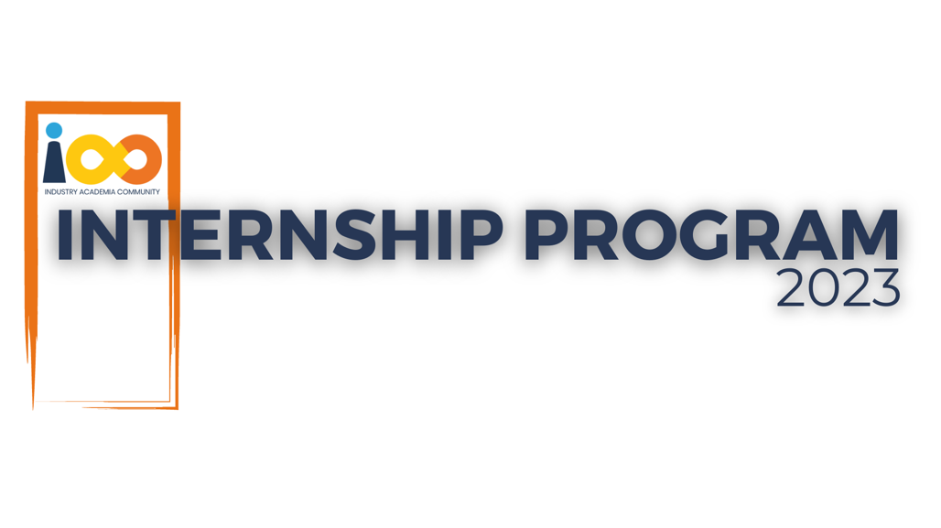

PROJECT REPORT

MACHINE LEARNING  
  
1. Student Placement Prediction System

2. Career Path Prediction and Guidance System

|  |  |  |  |
| --- | --- | --- | --- |
| **Created By:** | Prathamesh Narendra Bawane | **Approved By:** |  |
| **Created On:** | 10-05-2025 | **Approved On:** |  |

**INDEX**

**1** **PROJECT DETAILS** 2

**2** **SUMMARY** 2

**3** **INTRODUCTION** 2

3.1 Background 2

3.2 Stakeholders 2

3.3 Objectives 2

**4** **METHODOLOGY** 2

4.1 Considerations & Assumption 3

4.2 Approach 3

4.3 Activities 3

**5** **TARGETTED V/S ACHIEVED OUTPUT** 3

**6** **CONCLUSION** 3

**7** **APPENDICES** 4

7.1 Appendix A – Title 4

# **PROJECT DETAILS**

|  |  |  |  |
| --- | --- | --- | --- |
| **Project Name** | 1. Career Path Prediction and Guidance System 2. Student Placement Prediction System | | |
| **Project Sponsor** | Cloud Counselage Pvt. Ltd. | | |
| **Project Manager** | Prathamesh Narendra Bawane | | |
| **Start Date** | 05-06-2024 | **Completion Date** | 31-08-2024 |

# **SUMMARY**

This internship project involved the development of two machine learning systems aimed at providing intelligent insights for students: a Career Path Prediction and Guidance System, and a Student Placement Prediction System. These projects addressed critical needs—helping students make informed career decisions and enabling institutions to identify students who may require additional support in securing placement. Both systems use real-world student data, leveraging machine learning models for classification and recommendation. The long-term benefit lies in the deployment of such tools in academic institutions and training centers to support students in achieving better outcomes.

# **INTRODUCTION**

## Background

Students today face challenges in identifying the right career paths and preparing

for job placements due to a lack of personalized guidance and data-driven insights.

The Career Path Prediction system helps map individual profiles to suitable career

domains, while the Placement Prediction system forecasts placement likelihood

based on academic and extracurricular parameters.

## Stakeholders

* + Intern: Prathamesh Narendra Bawane
  + Internship Mentor / Domain Guide at Cloud Counselage
  + Academic Institutions (Future Users)
  + Students (End Users)

## Objectives

* + To predict suitable career paths using machine learning algorithms.
  + To develop a predictive system to estimate a student's placement probability.

# **METHODOLOGY**

## Considerations & Assumption

* + Data quality and completeness were assumed to be consistent.
  + Remote work environment was considered for all coordination and submissions.
  + Assumed access to platforms like Google Colab and GitHub for development and deployment.

## Approach

A structured machine learning pipeline was followed—data gathering,

preprocessing, model selection, training, evaluation, and final deployment.

For Career Path Prediction, supervised learning models were explored. For

Placement Prediction, both traditional ML and deep learning methods were

applied.

## Activities

* Problem understanding and dataset analysis
* Data preprocessing and feature engineering
* Model building and evaluation
* Documentation of project deliverables
* Hosting all project materials on GitHub
* Final report preparation and submission

# **TARGETTED V/S ACHIEVED OUTPUT**

|  |  |  |  |
| --- | --- | --- | --- |
| **Deliverables** | **Targeted** | **Achieved** | **Remarks** |
| Career Path Prediction System | Functional recommendation | Achieved with good accuracy | No major deviation |
| Placement Prediction System | Functional classification | Achieved using DL models | Slight variation in model output |
| Project Documentation (6 logs) | All logs prepared | Completed and submitted | On time |
| GitHub Repository with source files | Complete source and report | Uploaded | Shared for final review |

# **CONCLUSION**

These two projects have practical applications in academic guidance and training. The Career Path system supports students in making data-driven career choices, while the Placement Prediction model allows institutions to proactively support students at risk. Both solutions lay a strong foundation for scalable, intelligent educational tools. Future work may involve integrating these systems into web or mobile applications and improving accuracy with larger datasets.

# **APPENDICES**

## Appendix A – Title

|  |  |  |  |
| --- | --- | --- | --- |
| **Sr. No.** | **Deliverable Name** | **Format** | **Status** |
| 1 | Work Breakdown Structure | PPT (PDF) | Completed |
| 2 | Project Schedule | Excel | Completed |
| 3 | RAID Log | Excel | Completed |
| 4 | Development Log | Excel | Completed |
| 5 | Lessons Learned Log | Excel | Completed |
| 6 | Project Report | Word Doc | Completed |
| 7 | Source Code | Jupyter/IPYNB | Completed |
| 8 | GitHub Repository | Online | Completed |